

Answers Key Exercises Mplus
Exercise 1: the WAMBS-checklist
Step 1: Do you understand the priors?
Table 1. Do you understand the priors?
Parameters | Distributional form of the priors  (e.g., normal, inverse gamma, etc) | Type of prior  (non-, weakly, highly informative) | Source of background information | Picture of Plot | Hyperparameters
Intercept Lag | Normal | Informative | Previous articles | 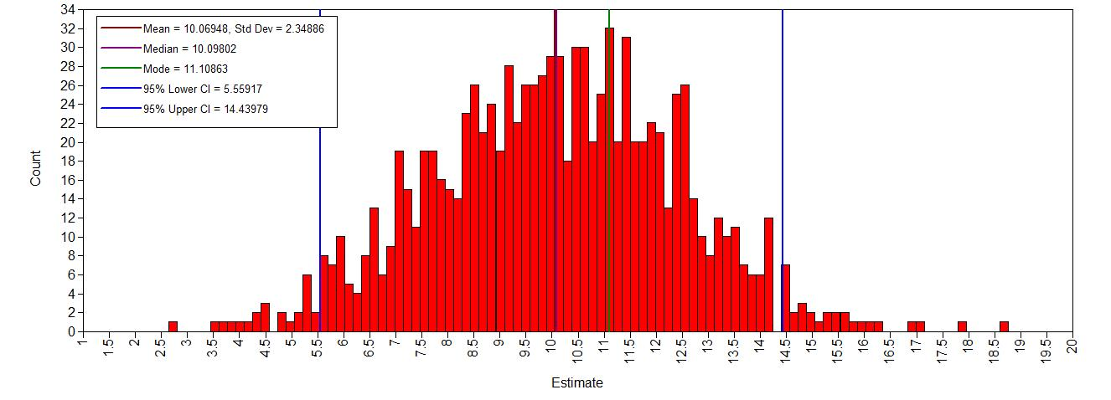 | N(10, 5)
Lag on Age | Normal | Weakly informative | Previous articles | 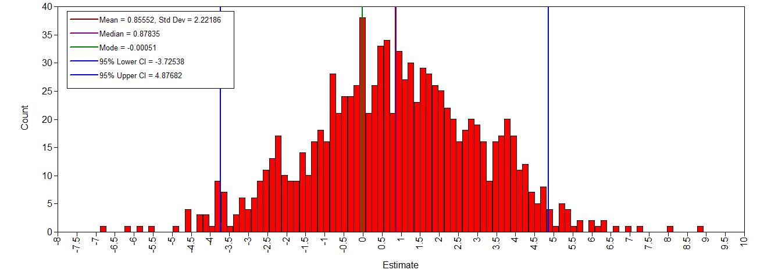 | N(.8,5)
Lag on Age_sq | Normal | Weakly informative | Previous articles | 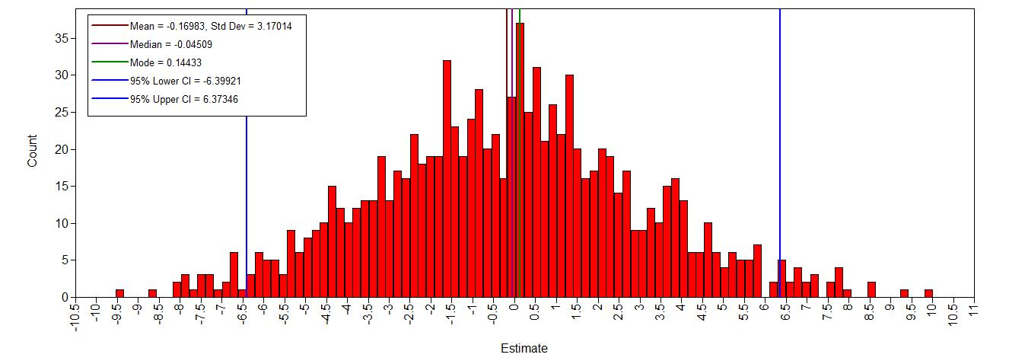 | N(0,10)
Res variance Lag | Inverse Gamma | Informative | Previous articles | 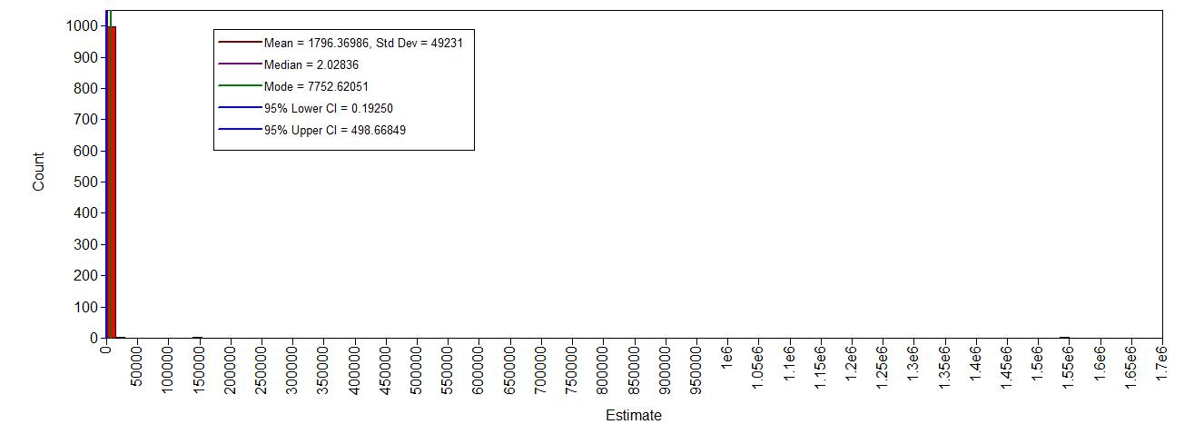 | IG(.5,.5)

Step 2: run the model and check for convergence
Table 2.
Parameters | Trace plot | Histogram | Autocorrelation  Plots | Kernel density plot
Intercept Lag | 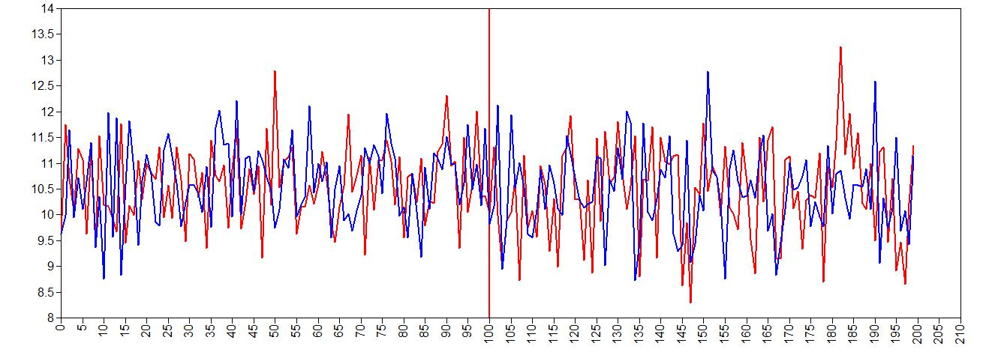 | 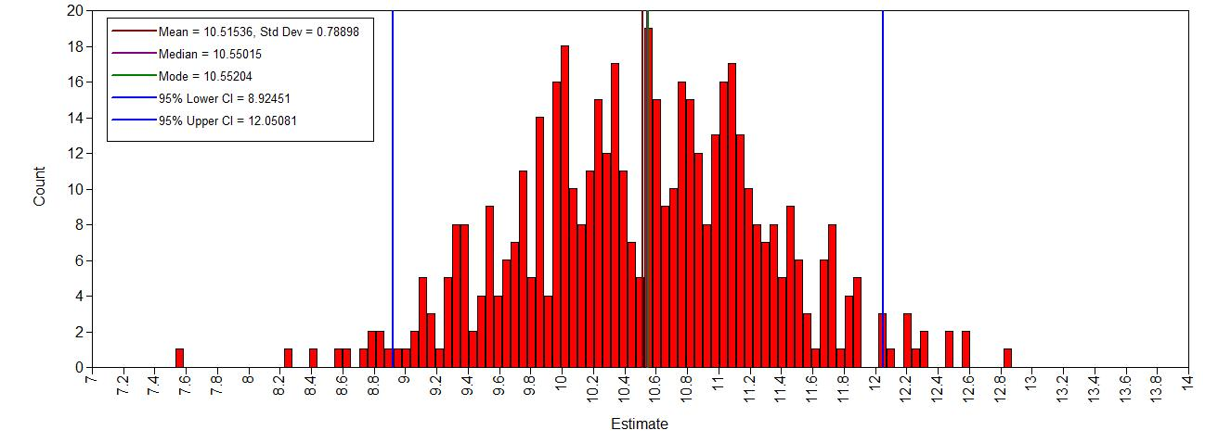 | 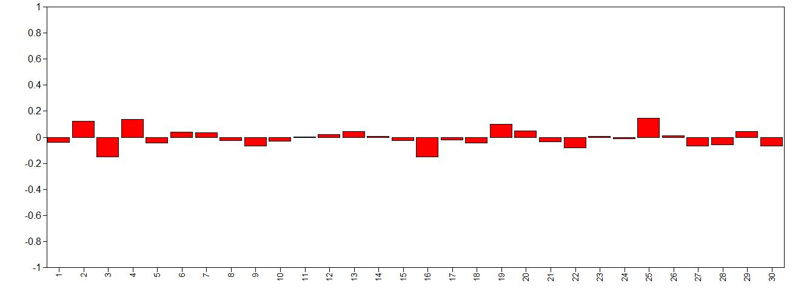 | 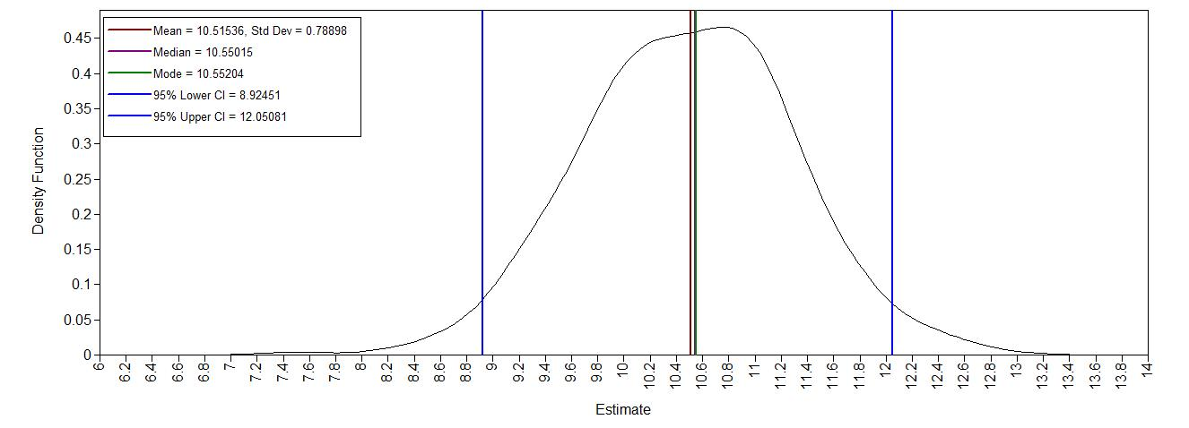
Lag on Age | 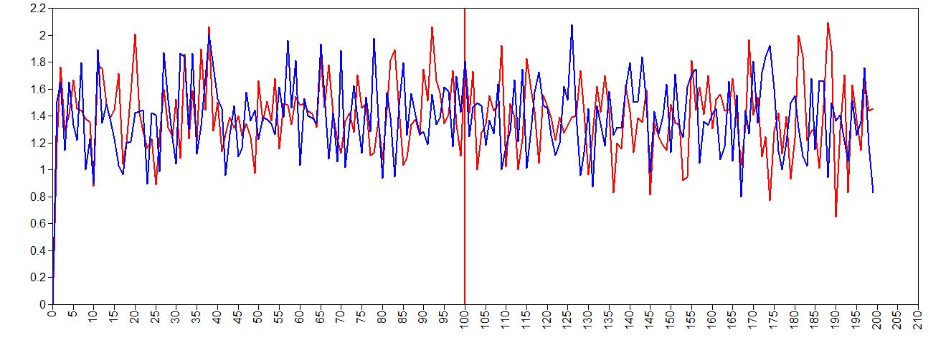 | 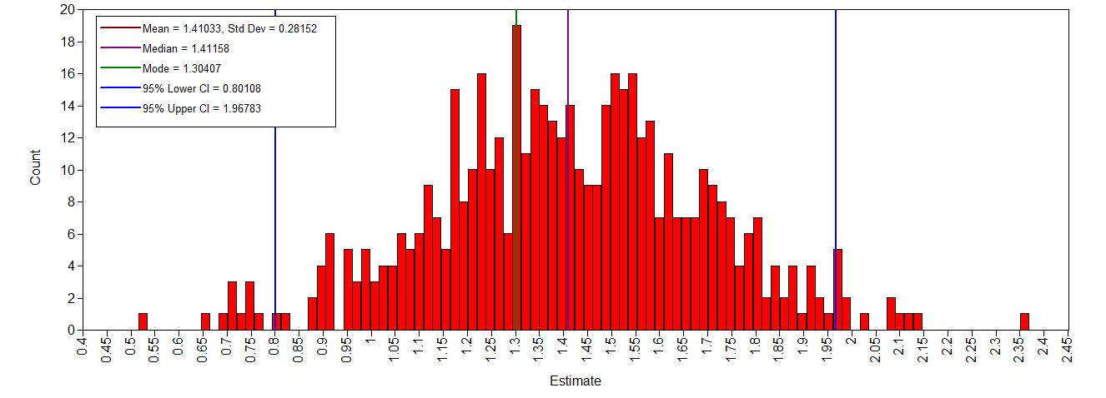 | 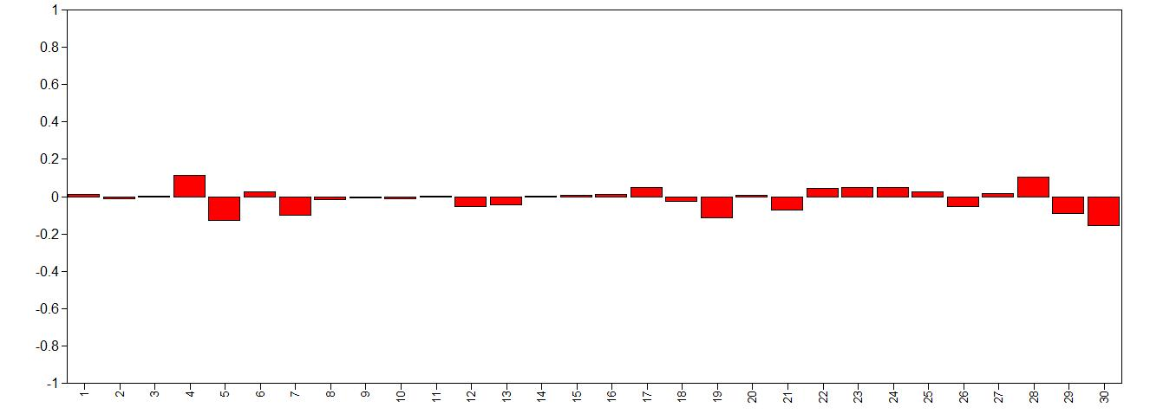 | 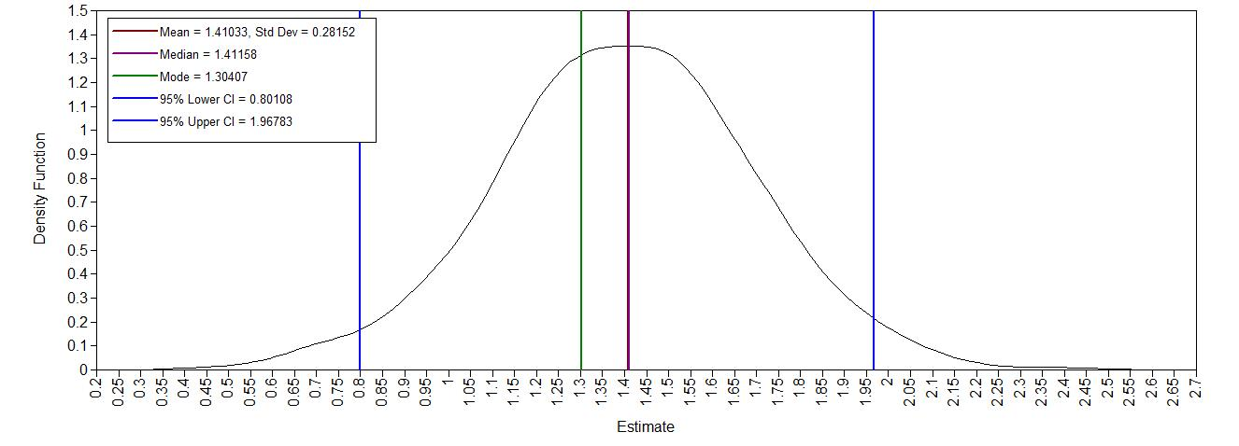
Lag on Age_sq | 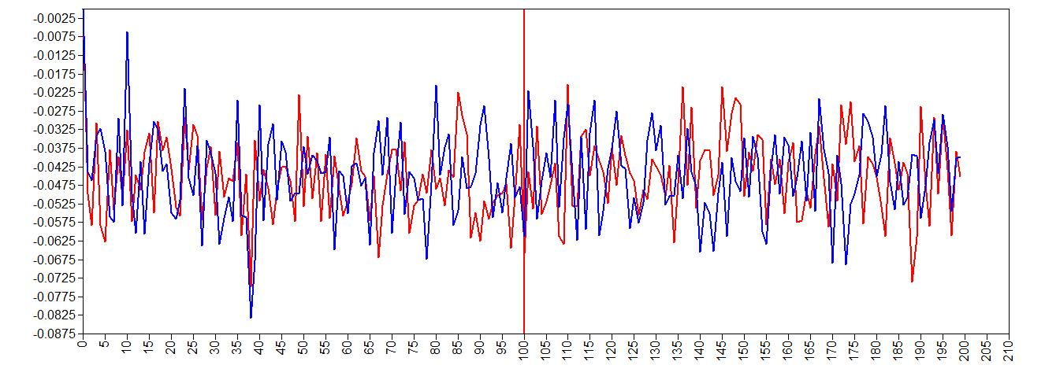 | 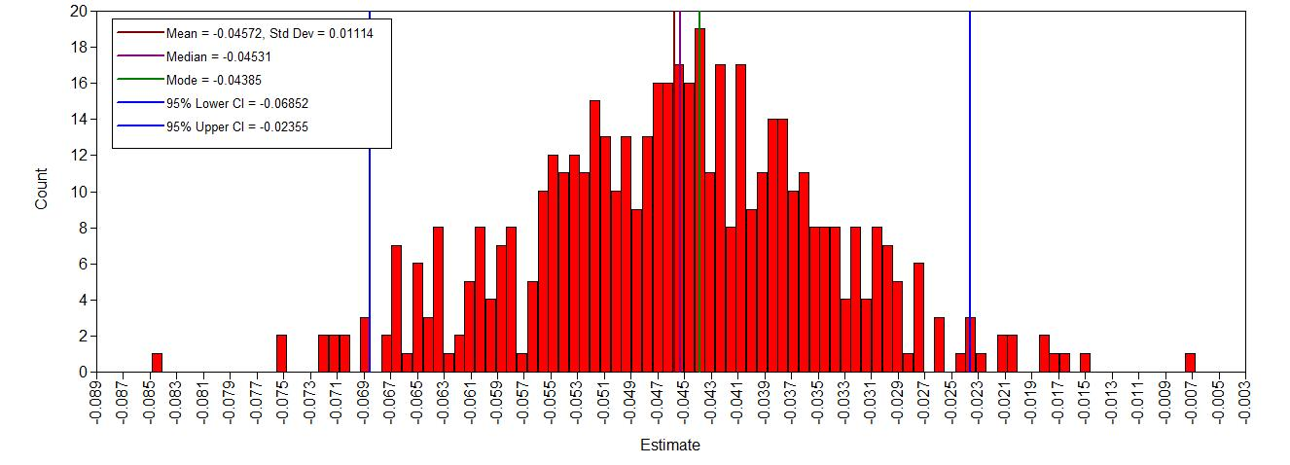 | 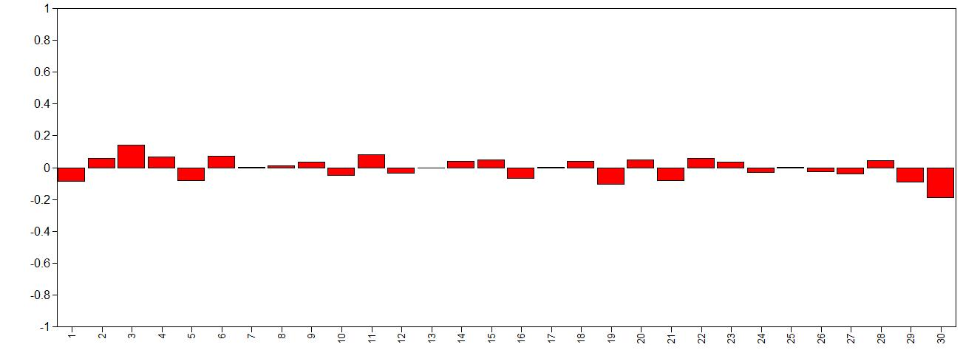 | 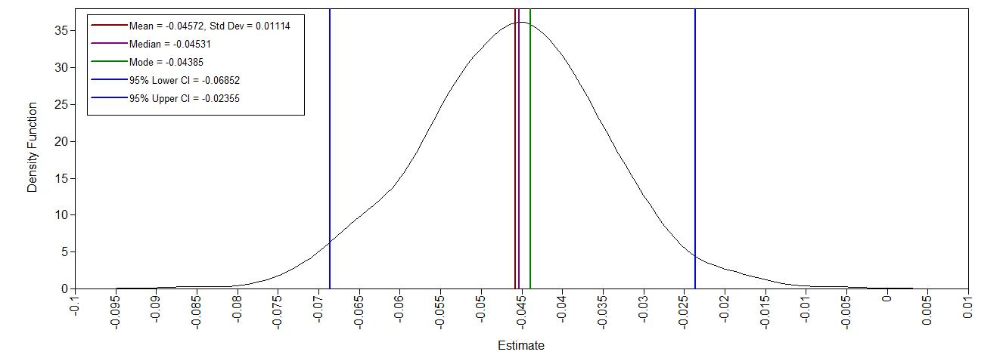
Res variance Lag | 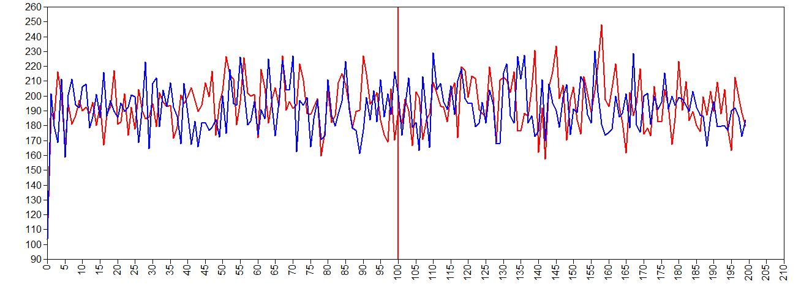 | 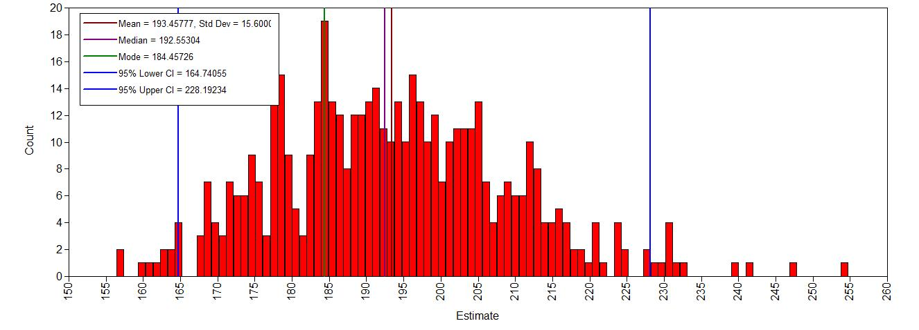 | 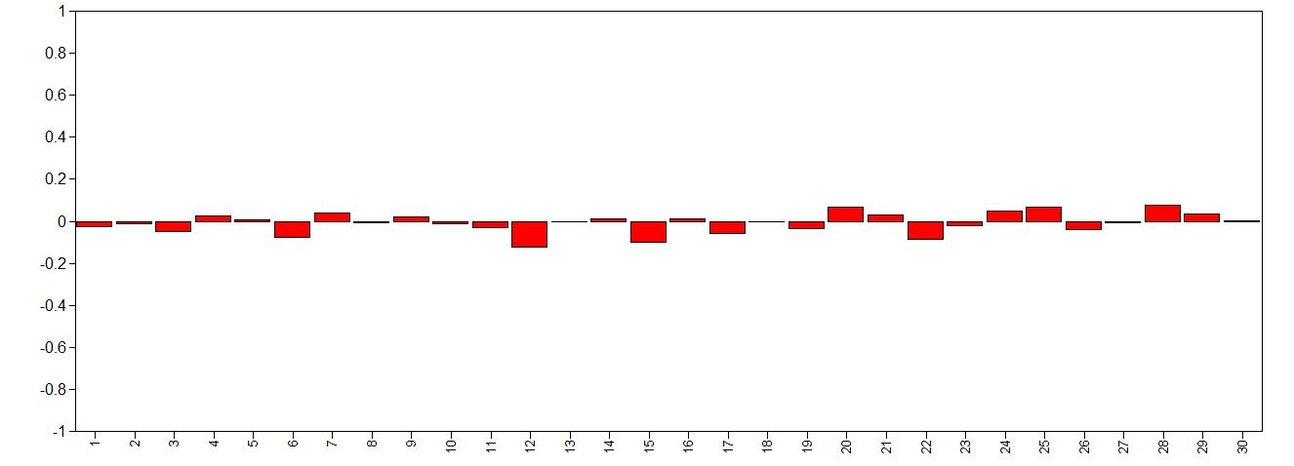 | 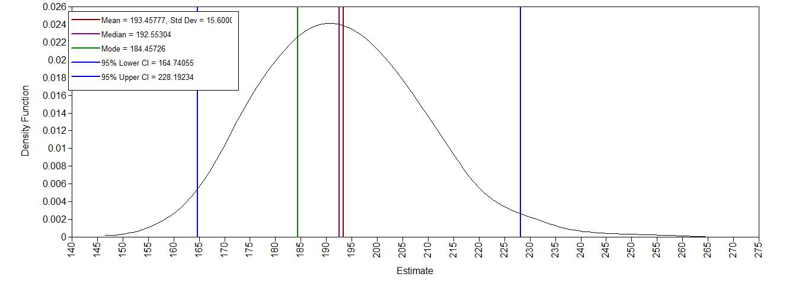

Step 3: doubling the number of iterations and convergence diagnostics
Did the model reach convergence?
The final Gelman and Rubin diagnostic is 1.000, but even for the first 100 the PSR is < 1.05. So, according to this statistic, the model has reached convergence.
Computing Bias:
Parameters | Estimate Model with 200 iterations | Estimate Model with 500 iterations | Bias
Lag intercept | 10.452 | 10.550 | 0.94%
Lag on age | 1.392 | 1.412 | 1.44%
Lag on age_sq | -0.044 | -0.045 | 2.27%
Res var. Lag | 192.421 | 192.553 | 0.07%

Looking at the bias, not much has changed in the estimates between 200 and 500 iterations. This seems to indicate that the model estimates are quite stable, supporting the decision that this model has converged.

Step 4: Does the posterior distribution histogram have enough precision?
The histograms appear to have enough precision to be relatively smooth, so there is no need for more iterations.

Step 5: Do the chains exhibit a strong degree of autocorrelation?
Autocorrelation is relatively small over lags (largest absolute values is below .20), so we don’t need more iterations.

Step 6: Does the posterior distribution make substantive sense?
The means of the distributions are relatively close to the prior means and the standard deviations of the priors are larger than the standard deviations of the posteriors. Therefore, the 95% CCIs of the posterior fit in the 95% CCIs of the prior distributions. As the prior distributions are assumed to make sense, these posteriors should also make sense.

Step 7: Do different specification of the multivariate variance priors influence the results?
Parameters | Estimate Model with 500 iterations, IG(.5,.5) | Estimate Model with 500 iterations, IG(.001,.001) | Bias
Lag intercept | 10.550 | 10.550 | 0%
Lag on age | 1.412 | 1.411 | -0.07%
Lag on age_sq | -0.045 | -0.045 | 0%
Res var. Lag | 192.553 | 193.189 | 0.33%
Looking at the bias percentages, it doesn’t seem that making the prior for the residual variance less informative has much effect on the posterior estimates. This indicates that either the data has a stronger influence on the posterior distribution than the prior does, OR that the data and prior are perfectly aligned even if you make the prior less informative.

Step 8: Is there a notable effect of the prior when compared with non-informative priors?
An improper prior means that the function does not integrate to 1. MPlus regards a normally distributed prior with variance 10^10 as a prior with infinite variance, and therefore it is an improper prior.
Looking at the Gelman and Rubin diagnostic, the model has reached convergence (PSR = 1.000 after 500 iterations). This is further supported by the traceplots of the parameter estimates.
Bias:
Parameters | Estimate Model with 500 iterations, informative priors | Estimate Model with 500 iterations, noninformative priors | Bias
Lag intercept | 10.550 | 10.624 | 0.70%
Lag on age | 1.412 | 1.427 | 1.06%
Lag on age_sq | -0.045 | -0.046 | 2.22%
Res var. Lag | 192.553 | 193.263 | 0.37%
The influence of the prior on the posterior is small. The bias never exceeds +/- 10%. Since the original priors were based on previous research, I would use those, so we can further our knowledge on this topic, instead of starting from scratch (since Bayes with default priors is almost the same as ML)

